Systematic Review Running title : HDV in IRAN

Regional Distribution of Hepatitis Delta Virus in Iran: A Systematic Literature Review
Abbas Esmaeilzadeh^{1,2}, Ladan Goshayeshi^{1,3*}, Ali Bahari^{1,2}, Azita Ganji^{1,2}, Hooman Mosannen Mozaffari^{1,2}
¹Gastroenterology and Hepatology Department, Faculty of Medicine, Mashhad University of Medical Sciences, Mashhad, Iran
²Gastroenterology and Hepatology Research Center, Mashhad University of Medical Sciences, Mashhad, Iran
³Surgical Oncology Research Center, Mashhad University of Medical Sciences, Mashhad, Iran

*Corresponding Author:
Ladan Goshayeshi, MD
Associate Professor, Department of Gastroenterology and Hepatology, Mashhad University of Medical Sciences, Mashhad, Iran
Tel: + 98 5138598818
Fax: + 98 5138932481
E-mail: goshayeshil@mums.ac.ir
Received : 06 Dec. 2016
Edited : 14 Feb. 2017
Accepted : 15 Feb. 2017

Please cite this paper as:
Esmaeilzadeh A, Goshayeshi L, Bahari A, Ganji A, Mosannen Mozaffari H. Regional Distribution of Hepatitis Delta Virus in Iran: A Systematic Literature Review. Govaresh 2017;22:???????
ABSTRACT
Background
Hepatitis delta virus (HDV) is an RNA virus that causes hepatitis. Since HDV is dependent on hepatitis B virus (HBV) for its pathogenesis, two major types of HDV and HBV infection is coinfection with HBV in anti-HBs negative individuals, or superinfection in chronic HBV carriers. Therefore, the prevalence of HDV depends on the frequency of HBV infection in various populations. In this study, we aimed to systematically review the prevalence of HDV in Iran.
Materials and Methods
A systematic literature search was performed in August 2016 in PubMed, Scopus, and Iran Medex using the following keywords (((hepatitis delta virus OR HDV)) AND (prevalence OR frequency OR distribution OR epidemiology)) AND Iran to investigate the prevalence of HDV in Iran. After literature search and selection of appropriate documents, the desired data were extracted and described.
Results
A total of 14 articles with overall 6300 study population with HDV infection were collected. The results of this study showed that the prevalence of HDV varied from zero in the north to 19.7% in the south of Iran (in HIV infected patients).
Conclusions
The prevalence of HDV was relatively high among Iranian patients with chronic HBV infection. Furthermore, the results of this study showed that the prevalence of HBV/HDV coinfection has increased during the last decade in Iran.
Keywords: Hepatitis D virus, HDV antigen, Coinfection, Superinfection

Introduction
Hepatitis delta virus (HDV), which causes hepatitis, is an RNA virus that is structurally different from other types of hepatitis viruses(1). HDV is classified into seven genotypes by using molecular sequence analyses(2). For life cycle, attachment, and entry of HDV into the host cells, it is dependent on hepatitis B virus (HBV); hence, HDV infection is only among people with HBV infection(3). Therefore, the incidence of HDV infection is rather high in societies with higher prevalence of HBV. Since the incidence of HDV infection is dependent on HBV, two specific patterns of infection including coinfection with HBV in anti-HBs negative individuals, or superinfection in chronic HBV carriers can be described for HDV infection(4). Transmission of hepatitis D is typically through percutaneous or mucosal exposure to infected blood. Since no vaccine available for hepatitis D, conventional treatments for HBV infection and vaccination for HBV is considered as the primary line of defense to prevent HDV infection(5,6).
HDV infection occurs in a few hepatitis B carriers. Since its discovery in 1977, the global prevalence of HDV has increased to around 20 million(2). Drug abuse by intravenous (IV) injection, infection in pregnancy, HBV infection, sexual transmission, and blood transfusions are the major risk factors and routes of virus transmission in HDV infection(7). Studies have shown that coinfection of HBV and HDV can lead to a more severe form of acute hepatitis that has higher mortality rate compared with HBV infections alone(8). Clinical manifestations of HDV vary from acute and self-limited infections to chronic liver associated complications and liver failure. However, possible symptoms of HDV infection include abdominal pain, dark urine, fatigue, joint pain, loss of appetite, nausea, and vomiting. Diagnosis of HDV infection is based on the detection of HDV Ab, and HDV RNA in the blood and increase in the plasma levels of liver enzymes(1).
Since the occurrence of HDV infection depends on the prevalence of HBV, the frequency of HDV infection varies among populations according to HBV prevalence. Epidemiological studies have shown that the incidence of HDV may be up to 5% of HBV infected individuals(7). Since there is no recent comprehensive report on the prevalence of HDV in Iran since 2013, in the present study, regional distribution of HDV was systematically reviewed among Iranian population.
MATERIALS AND METHODS
Methodology and selection criteria
To perform a comprehensive systematic search on the prevalence of HDV in Iran, the following terms “hepatitis Delta virus OR HDV”, “prevalence OR frequency OR distribution OR epidemiology”, and “Iran” were systematically searched in the title, abstract, and keywords of documents within the PubMed, Scopus, and Iran Medex. The literature search was performed in August 2016. The search method was customized where the results were limited to only articles with Persian and English languages. No strict limitations were defined to collect all eligible documents and to reduce possible data loss during study selection. Hence, all relevant articles with all types of clinical design in which the prevalence of HDV was reported in Iran, were included and used for qualitative data assessment. As well, the reference lists of the included documents were searched manually for potentially appropriate documents. However, conference papers, letters, review articles, and meta-analyses were excluded from further data assessment. Articles irrelevant to the main purpose of this survey were excluded. Moreover, documents with duplicated data were excluded from further evaluation. Therefore, according to the above-mentioned items, the exclusion criteria in this review were as follow:
- Articles with languages other than English and/or Persian
- Letters, conference abstracts, and review articles
- Articles with subject irrelevancy and/or data inadequacy
- Duplicated documents
All procedures of literature search, article selection, and data extraction were performed according to checklist , by two reviewers independently(9). For this purpose and to avoid possible misinterpretation during data analysis, any probable discrepancies between the authors were resolved in each step before further data processing.

Data synthesis
All general information including the name of authors, publication date, region, and demographic data of the studied population, in addition to the total number of study patients in each study was extracted. Other informative data including methods of evaluation, study variables, and the key findings of each study were extracted and reported based on the main purpose of this study.
Methods of assessment and measured variables
Various biochemical, immunological, and molecular methods can be used for the diagnosis of hepatitis infection. Enzyme-linked immunosorbent assay (ELISA) and liver functional tests had been frequently used among the included documents for the diagnosis of HBV and HDV. In addition, polymerase chain reaction (PCR), restriction fragment length polymorphism (RFLP), reverse transcription-polymerase chain reaction (RT-PCR), as well as semi-nested PCR and real-time PCR had also been used as confirmatory tests in some of the included documents to determine the seroprevalence of HBV and HDV. Variables including hepatitis B surface antigen (HBsAg), anti-HDV antigen, HDV RNA, alanine aminotransferase (ALT), and aspartate aminotransferase (AST) had been evaluated in the included studies. Moreover, immunoglobulin levels of the serum against HDV (IgG and IgM) were also evaluated in HBV infected patients. Age, sex, marital status, smoking, tattooing, socioeconomic status, history of drug abuse, social and sexual behavior, blood transfusion, parenteral exposure to blood or blood products, periodontal procedures and surgery, and history of viral hepatitis, endoscopy, and colonoscopy were also recorded in some studies as possible risk factors for HDV infection.
RESULTS
Literature search and study selection
Through the search in the electronic databases, a total of 118 articles were collected, of which 32 articles were found in the PubMed, 63 in the Scopus, and 21 potentially relevant articles were in Iran Medex. Two additional eligible documents were also found through manual reference list screening of the collected documents. By reviewing the titles and abstracts of the collected articles and according to the defined selection criteria, 53 documents with subject irrelevancy were excluded in the first step. Additional 35 articles were also excluded due to data inadequacy and duplication. After limiting the records to the articles published in English and/or Persian languages, two additional articles were excluded from the collected documents pool. Moreover, 14 review articles were excluded from additional assessment. Finally, full texts of 14 articles, in which the seroprevalence of HDV had been investigated in different geographical regions of Iran, were fully reviewed and used for additional data assessment. The step by step process of literature search and documents selection is summarized in figure 1.

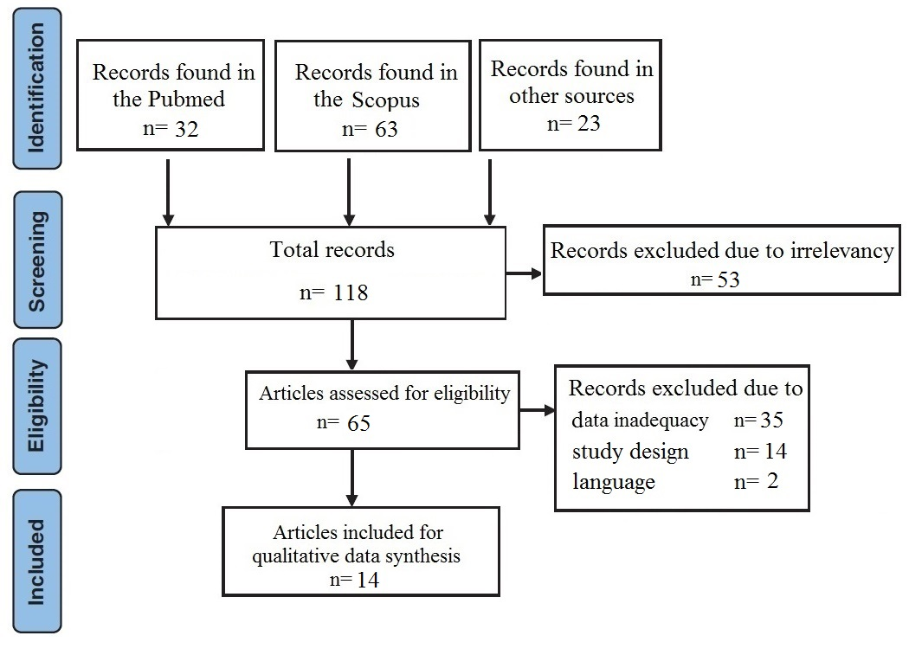
Fig. 1: Flowchart of the literature search and strategy for the selection of relevant documents

Description of included studies
The total number of study population in the selected documents in which the prevalence of HDV had been investigated in different areas of Iran was 6300. Of the total 6300 patients, 2718 were male and 1117 were female, but the sex of the other 2465 patients had not been reported. The number of studied patients varied from 48 to 1268 in different included articles. The age of the studied patients also varied from 17 to 65 in different studies. The most old and recent articles that were included in this survey had been published in 1993 and 2015, respectively. General information and detailed characteristics of the included articles are summarized in table 1 in their chronological order of publication time.
The results of this study showed that the prevalence of hepatitis D infection in Iran is rather high in some areas. Moreover, the results showed that some of HDV positive patients had a history of blood transfusion, tattooing, surgery, and dental surgery(10). Our findings also showed that anti-HDV can be found both in HBe antibody-positive patients and in HBe antigen-positive cases. However, it was shown that the prevalence of HDV infection is higher in HBe antibody-positive patients than patients with HBe antigen-positive(11). The results of the included articles showed that the prevalence of HDV varied from 0.03% in Qom province (central Iran) to 19.7% in HIV infected patients in Shiraz (south of Iran) (7,10). Moreover, no HDV seropositive case was reported among patients with positive hepatitis B surface antigen in Mazandaran (north of Iran), indicating that HDV is not endemic in this area(12). Also, reports demonstrated that the prevalence of HDV was higher among female HBV infected individuals; however, the difference was not significant(13). Also, our findings have shown that the prevalence of HDV infection is relatively higher among patients with chronic liver disease and HIV/HBV coinfected population(7,14). The main findings of each study, in addition to the study variables, target population, and the prevalence of HDV are summarized in table 2.
Qualitative data assessment of the included articles and study on seroepidemiology of HDV showed that the prevalence of HDV was rather high in Iran; however, it is recommended to perform further comprehensive epidemiological studies on the prevalence of HDV in different areas of Iran. The prevalence of HDV in different regions of Iran is demonstrated in figure 2.
Table 1: General information of the included articles
No | First author | Year | Province | Mean age* | Sex ratio *  Male/female | Number of participants
1 | Motamedifar M (7) | 2015 | Shiraz | 37.4±7.4 | 175/3 | 178
2 | Tahaei SM (27) | 2014 | Tehran | 40.03±14.93 | 278/231 | 509
3 | Attaran MS (28) | 2014 | Tehran | 38 | 657/197 | 854
4 | Keshvari M (26) | 2014 | Tehran | ND | 576/84 | 660
5 | Ziaee M (16) | 2013 | Birjand | 38.5±11.9 | 231/182 | 413
6 | Bakhshipour A (14) | 2013 | Zahedan | 40.5±14.6 | 302/138 | 440
7 | Ghadir MR (10) | 2012 | Qom | ND | 27/21 | 48
8 | Ataei B (11) | 2011 | Isfahan | 39±12.4 | 245/101 | 346
9 | Mohammad Alizadeh AH (29) | 2010 | Hamedan | 35.6±14.7 | 55/26 | 81
10 | Hosseini SMAR (30) | 2010 | Mashhad | ND | ND | 350
11 | Somi MH (31) | 2009 | Tabriz | 38.9±14.6 | ND | 847
12 | Taghvaei T (12) | 2008 | Mazandaran | 35.52±14.03 | 104/63 | 167
13 | Roshandel G (13) | 2007 | Golestan | 41.89±11.30 | 68/71 | 139
14 | Amini S (25) | 1993 | Hamedan | ND | ND | 1268
* ND: Not described. |  |  |  |  | Male: 2718  Female: 1117 | No= 6300

Table 2: The main findings and the reported prevalence of HEV in different areas of Iran
No | First author | Variables® | Methods | Prevalence (%) | Findings
1 | Motamedifar M (7) | HDV Ab, AST, ALT, HBsAg | SA, ELISA | 19.7 | Relatively high prevalence of HDV infection is reported in HIV infected population in Shiraz.
2 | Tahaei SM (27) | HDV Ab | ELISA, LFT | 7.7 | HDV seroprevalence changes over time.
3 | Attaran MS (28) | HDVAb, HDV RNA | ELISA, RFLP, RT-PCR, SnPCR | 2 | More superinfection with HBV was reported than coinfection.
4 | Keshvari M (26) | HDV RNA, HDV Ab, PC, ALT, AST | RT-PCR, LT, ELISA | 2.2 | Familial history of hepatitis D infection was more observed in HDV-seropositive patients.
5 | Ziaee M (16) | HDV Ab | ELISA | 3.1 | HDV had a low prevalence in Birjand.
6 | Bakhshipour A (14) | HDV Ab, HDV RNA | ELISA, LFT | 17 | The prevalence of HDV was higher in patients with cirrhosis.
7 | Ghadir MR (10) | A-HDVAb, HBsAg | ELISA | 0.03 | The prevalence of hepatitis D in Qom is the lowest in Iran.
8 | Ataei B (11) | A-HDV Ab | ELISA | 3.5 | The prevalence of HDV infection is higher in patients who are positive for HBeAb compared with those who are HBeAg positive.
9 | Mohammad Alizadeh AH (29) | HDV Ab | ELISA | 17.3 | Relatively high rate of hepatitis B virus (HBV) and HDV co-infection was reported in this study.
10 | Hosseini SMAR (30) | HDV Ab, ALT, AST | ELISA | 10 | HDV infection is prevalent in the north-east of Iran.
11 | Somi MH (31) | HDV Ab, ALT, AST | ELISA, LFT | 9.3 | The incidence of HDV infection in Iran is declining over the time.
12 | Taghvaei T (12) | HDV Ab | ELISA | 0 | HDV is not endemic in Mazandaran.
13 | Roshandel G (13) | HDV Ab | ELISA | 5.8 | Seroprevalence of anti-HDV in the present study was higher than some previous studies from other parts of Iran.
14 | Amini S (25) | HDV Ab | ELISA | 2.4 | Socioeconomic conditions are important risk factors in hepatitis infection.
HBsAg: Hepatitis B surface antigen, A-HDVAg: anti- hepatitis delta virus antigen, HDV Ab: Hepatitis delta virus antibody, ALT: Alanine aminotransferase, AST: Aspartate aminotransferase, PC: Platelet count.
ELISA: Enzyme-linked immunosorbent assay, PCR: Polymerase chain reaction, RFLP: Restriction fragment length polymorphism, SA: Serological assays, SnPCR: Semi-nested PCR, RT-PCR: Real-time PCR, LFT: Liver function test, LT: Laboratory test.

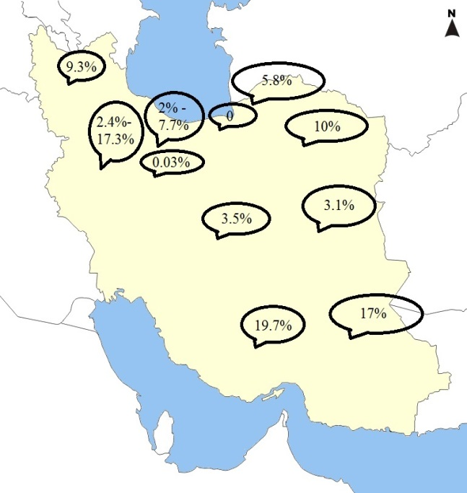

Fig. 2: The prevalence of HDV in different
geographical regions of Iran

DISCUSSION
HDV is an RNA virus that can only cause infection in the presence of HBV. HDV can aggravate the pre-existing HBV-associated liver disease(4). In addition, HDV causes hepatitis D that its clinical manifestation differs according to the mode of infection. Also, since coinfection or superinfection of HDV with HBV may lead to different virological and immunological responses, different clinical manifestations associated with HDV infection can be considered(15). However, it is suggested that HDV infection can exacerbate HBV-associated liver disease, progression of liver fibrosis, and development of hepatocellular carcinoma(16). HBV and HDV co- and superinfections are serious health problems worldwide, and the outbreak of HBV/HDV coinfection has been reported in several areas, particularly in northern South America(17). Similarly, the results of the present study also showed that HDV infection as an important public health problem can be considered as a major cause of HBV-associated liver disease(14). Epidemiological studies have shown that HDV infection is endemic in some parts of the world, especially in the Mediterranean area, the Middle East, and some parts of Africa(18). Findings show that the prevalence of HDV is high in western countries, particularly among intravenous drug addicts with HBV infection(19). Epidemiological findings have also shown that Turkey (<5% in western turkey to >27% in south east) and Mongolia are among countries with particularly high prevalence of HDV infection where one third of the population with hepatitis in Mongolia are known to be HDV infected (20, 21). On the other hand, studies have shown that the prevalence of hepatitis D is decreasing in southern Europe; however, high HDV seroprevalence in these areas is attributed to immigration(22). For example, it is estimated that more than three quarters of the patients with hepatitis D infection in Germany are immigrants from other countries where HDV is endemic (19). Genotype analysis of HDV genome has shown that the prevalence of HDV genotype I was higher than genotype II (83.3% vs. 16.7%) among Iranian population(23). Although the results of the present survey demonstrated that genotype I is responsible for most of HDV infection in Iran, reports have shown that other genotypes, especially genotype III was more prevalent in South America(17, 24).
The results of the present review showed that several risk factors such as familial history of hepatitis B, hepatitis D, or other liver diseases such as cirrhosis, blood transfusion, surgery, dental interventions, Hejamat (a traditional phlebotomy), socioeconomic status, history of imprisonment, tattooing, and intravenous drug use can be considered as the main causes of HDV infection in Iran(7,10,25,26). Although some studies have shown that the risk of HDV infection is increased with age; nevertheless, no significant association was found between seropositivity of anti-HDV and age, marital status, and place of residence(13,25). In addition, the results of this study indicated that most of HDV positive patients in Iran are HBe Ab positive(11).
The results of this review showed that the prevalence of HDV varies in different geographical regions along the time; hence, regular epidemiological studies are recommended to real time monitoring of HDV infection.
CONCLUSION
Based on the results of this review, the prevalence of HDV varies from zero in the north of Iran to near 19.7% in the south of the country (in HIV infected patients), which is rather high.

REFERENCES

1.Alavian SM, Alavian SH. Hepatitis D Virus Infection; Iran, Middle East and Central Asia. Hepat Mon 2005;5:137-43.

2.Radjef N, Gordien E, Ivaniushina V, Gault E, Anais P, Drugan T, et al. Molecular phylogenetic analyses indicate a wide and ancient radiation of African hepatitis delta virus, suggesting a deltavirus genus of at least seven major clades. J Virol 2004;78:2537-44.

3.Taylor JM. Hepatitis delta virus. Virology. 2006;344:71-6.

4.Negro F. Hepatitis D virus coinfection and superinfection. Cold Spring Harb Perspect Med 2014;4:a021550.

5.Farci P. Delta hepatitis: an update. J Hepatol 2003;39Suppl1:S212-9.

6.Hoofnagle JH, di Bisceglie AM. The treatment of chronic viral hepatitis. New Engl J Med 1997;336:347-56.

7.Motamedifar MP, Taheri MM, Lankarani KBM, Gholami MB, Lari MAM, Faramarzi HM, et al. The Prevalence and Risk Factors of Hepatitis Delta Virus in HIV/HBV Co-Infected Patients in Shiraz, Iran, 2012. IranJ Med Sci 2015;40):448-53.

8.Hajiani E, Alavi SM. A review on epidemiology, diagnosis and treatment of hepatitis D virus infection. Jundishapur J Microbiol 2011;4:(رفرانس براساس فرمت نشریه گوارش اصلاح شود.)

9.Liberati A, Altman DG, Tetzlaff J, Mulrow C, Gøtzsche PC, Ioannidis JP, et al. The PRISMA statement for reporting systematic reviews and meta-analyses of studies that evaluate health care interventions: explanation and elaboration. Ann Intern Med 2009;151:W65-94.

10.Ghadir MR, Belbasi M, Heidari A, Sarkeshikian SS, Kabiri A, Ghanooni AH, et al. Prevalence of hepatitis d virus infection among hepatitis B virus infected patients in qom province, center of iran. Hepat Mon 2012;12:205-8.

11.Ataei B, Yazdani MR, Kalantari H, Yaran M, Nokhodian Z, Javadi AA, et al. Hepatitis D virus infection in Isfahan, central Iran: Prevalence and risk factors among chronic HBV infection cases. Hepat Mon 2011;11:269-72.

12.Taghvaei T, Khanlarpoor M, Mahdavi MR, Fakheri HT, Maleki I, Khalilian AR. Prevalence of positive Hepatitis Delta Virus in patients with positive Hepatitis B surface Antigen and its correlative factors in Sari. J Mazandaran Univ Med Sci 2008;18:102-6.

13.Roshandel G, Semnani S, Abdolahi N, Keshtkar AA, Besharat S, Joshaghani H, et al. Prevalence of hepatitis D virus infection in HBsAg positive subjects in Iran. Pak J Biol Sci 2007;10:1751-4.

14.Bakhshipour A, Mashhadi M, Mohammadi M, Nezam SK. Seroprevalence and risk factors of hepatitis delta virus in chronic hepatitis B virus infection in Zahedan. Acta Medica Iranica 2013;51:260-4.

15.Farci P, Niro GA. Clinical features of hepatitis D. Semin Liver Dis 2012;32:228-36.

16.Ziaee M, Azarkar G. Prevalence of hepatitis d virus infection among patients with chronic hepatitis B attending birjand hepatitis clinic (East of iran) in 2012. Hepat Mon 2013;13:e11168.

17.Casey JL, Niro GA, Engle RE, Vega A, Gomez H, McCarthy M, et al. Hepatitis B virus (HBV)/hepatitis D virus (HDV) coinfection in outbreaks of acute hepatitis in the Peruvian Amazon basin: the roles of HDV genotype III and HBV genotype F. J Infecti Dis 1996;174:920-6.

18.Casey JL, Brown TL, Colan EJ, Wignall FS, Gerin JL. A genotype of hepatitis D virus that occurs in northern South America. Proc Natl Acad Sci U S A 1993;90:9016-20.

19.Wedemeyer H, Heidrich B, Manns MP. Hepatitis D virus infection--not a vanishing disease in Europe! Hepatology 2007;45:1331-2; author reply 2-3.

20.Degertekin H, Yalcin K, Yakut M, Yurdaydin C. Seropositivity for delta hepatitis in patients with chronic hepatitis B and liver cirrhosis in Turkey: a meta-analysis. Liver Int 2008;28:494-8.

21.Tsatsralt-Od B, Takahashi M, Nishizawa T, Endo K, Inoue J, Okamoto H. High prevalence of dual or triple infection of hepatitis B, C, and delta viruses among patients with chronic liver disease in Mongolia. J Med Virol 2005;77:491-9.

22.Wedemeyer H, Manns MP. Epidemiology, pathogenesis and management of hepatitis D: update and challenges ahead. Nat Rev Gastroenterol Hepatol 2010;7:31-40

23.Sadeghian H, Varasteh N, Esmaeelzadeh A, Nomani H, Alimardani M, Davoodnejad M, et al. Distribution of hepatitis delta virus genotypes in mashhad, northeast iran. Jundishapur J Microbiol 2015;8:e14908.

24.Mohebbi SR, Zali N, Derakhshan F, Tahami A, Mashayekhi R, Amini-Bavil-Olyaee S, et al. Molecular epidemiology of hepatitis delta virus (HDV) in Iran: a preliminary report. J Med Virol 2008;80:2092-9.

25.Amini S, Mahmoodi MF, Andalibi S, Solati AA. Seroepidemiology of hepatitis B, delta and human immunodeficiency virus infections in Hamadan province, Iran: a population based study. J Trop Med Hyg 1993;96:277-87.

26.Keshvari M, Alavian SM, Aghaee B, Behnava B, Mahdavi M, Fesharaki MG, et al. Seroepidemiology and clinical features of hepatitis delta among HBsAg carriers: a study from Hepatitis Clinic of Iranian Blood Transfusion Organization. Transfus Med 2014;24:411-7.

27.Tahaei SM, Mohebbi SR, Azimzadeh P, Behelgardi A, Sanati A, Mohammadi P, et al. Prevalence of hepatitis D virus in hepatitis B virus infected patients referred to Taleghani hospital, Tehran, Iran. Gastroenterol Hepatol Bed Bench 2014;7:144-50.

28.Attaran MS, Sharifi Z, Hosseini SM, Samei S, Ataee Z. Prevalence of hepatitis B and hepatitis D coinfection in asymptomatic blood donors in Iran. APMIS 2014;122:243-7.

29.Mohammad Alizadeh AH, Ranjbar M, Tehrani AS, Keramat F, Mamani M, Rezazadeh M, et al. Seroprevalence of hepatitis D virus and its risk factors in the west of Iran. J Microbiol Immunol Infect 2010;43:519-23.

30.Hosseini SMAR, Esmaeilzadeh A, Mokhtarifard A, Sima HR, Vosoughinia H, Saadatnia H, et al. Seroepidemiology And Co- Infections of Hepatitis D Virus Infection in the North- East of Iran. Med J Mashhad Univ Med Sci 2010;53):69-72.

31.Somi MH, Farhang S, Miri SM, Pouri AA, Mjidi G, Alavian SM. The frequency of hepatitis D virus in patients with hepatitis B in Iran: an increasing rate? Trop Doct 2009;39:154-6.

Table 2: The main findings and the reported prevalence of HEV in different areas of Iran
No | First author | Variables® | Methods | Prevalence (%) | Findings
1 | Motamedifar M (7) | HDV Ab, AST, ALT, HBsAg | SA, ELISA | 19.7 | Relatively high prevalence of HDV infection is reported in HIV infected population in Shiraz.
2 | Tahaei SM (27) | HDV Ab | ELISA, LFT | 7.7 | HDV seroprevalence changes over time.
3 | Attaran MS (28) | HDVAb, HDV RNA | ELISA, RFLP, RT-PCR, SnPCR | 2 | More superinfection with HBV was reported than coinfection.
4 | Keshvari M (26) | HDV RNA, HDV Ab, PC, ALT, AST | RT-PCR, LT, ELISA | 2.2 | Familial history of hepatitis D infection was more observed in HDV-seropositive patients.
5 | Ziaee M (16) | HDV Ab | ELISA | 3.1 | HDV had a low prevalence in Birjand.
6 | Bakhshipour A (14) | HDV Ab, HDV RNA | ELISA, LFT | 17 | The prevalence of HDV was higher in patients with cirrhosis.
7 | Ghadir MR (10) | A-HDVAb, HBsAg | ELISA | 0.03 | The prevalence of hepatitis D in Qom is the lowest in Iran.
8 | Ataei B (11) | A-HDV Ab | ELISA | 3.5 | The prevalence of HDV infection is higher in patients who are positive for HBeAb compared with those who are HBeAg positive.
9 | Mohammad Alizadeh AH (29) | HDV Ab | ELISA | 17.3 | Relatively high rate of hepatitis B virus (HBV) and HDV co-infection was reported in this study.
10 | Hosseini SMAR (30) | HDV Ab, ALT, AST | ELISA | 10 | HDV infection is prevalent in the north-east of Iran.
11 | Somi MH (31) | HDV Ab, ALT, AST | ELISA, LFT | 9.3 | The incidence of HDV infection in Iran is declining over the time.
12 | Taghvaei T (12) | HDV Ab | ELISA | 0 | HDV is not endemic in Mazandaran.
13 | Roshandel G (13) | HDV Ab | ELISA | 5.8 | Seroprevalence of anti-HDV in the present study was higher than some previous studies from other parts of Iran.
14 | Amini S (25) | HDV Ab | ELISA | 2.4 | Socioeconomic conditions are important risk factors in hepatitis infection.
HBsAg: Hepatitis B surface antigen, A-HDVAg: anti- hepatitis delta virus antigen, HDV Ab: Hepatitis delta virus antibody, ALT: Alanine aminotransferase, AST: Aspartate aminotransferase, PC: Platelet count.
ELISA: Enzyme-linked immunosorbent assay, PCR: Polymerase chain reaction, RFLP: Restriction fragment length polymorphism, SA: Serological assays, SnPCR: Semi-nested PCR, RT-PCR: Real-time PCR, LFT: Liver function test, LT: Laboratory test.

